**REG NO. : 412422205009**

**NAME : AKASH RAJ L**

**SOURCE CODE :**

**akash.xml**

<employees>

<employee>

<id>101</id>

<name>John Doe</name>

<role>Developer</role>

<department>Engineering</department>

<salary>60000</salary>

</employee>

<employee>

<id>102</id>

<name>Jane Smith</name>

<role>Manager</role>

<department>Marketing</department>

<salary>75000</salary>

</employee>

<employee>

<id>103</id>

<name>Robert Brown</name>

<role>Analyst</role>

<department>Finance</department>

<salary>55000</salary>

</employee>

<employee>

<id>104</id>

<name>Emily White</name>

<role>Designer</role>

<department>Creative</department>

<salary>50000</salary>

</employee>

<employee>

<id>105</id>

<name>Michael Johnson</name>

<role>Sales Executive</role>

<department>Sales</department>

<salary>45000</salary>

</employee>

</employees>

**DOMParser1.java**

import javax.xml.parsers.DocumentBuilder;

import javax.xml.parsers.DocumentBuilderFactory;

import org.w3c.dom.*;

public class DOMParser1 {

public static void main(String[] args) {

try {

// Initialize DocumentBuilder

DocumentBuilderFactory factory = DocumentBuilderFactory.newInstance();

DocumentBuilder builder = factory.newDocumentBuilder();

// Load XML file using ClassLoader

ClassLoader classLoader = DOMParser1.class.getClassLoader();

Document document = builder.parse(classLoader.getResourceAsStream("akash.xml"));

// Normalize XML structure

document.getDocumentElement().normalize();

// Root element

System.out.println("Root element: " + document.getDocumentElement().getNodeName());

// Parse employee nodes

NodeList nodeList = document.getElementsByTagName("employee");

for (int i = 0; i < nodeList.getLength(); i++) {

Node node = nodeList.item(i);

if (node.getNodeType() == Node.ELEMENT_NODE) {

Element employee = (Element) node;

System.out.println("Employee ID: " + employee.getElementsByTagName("id").item(0).getTextContent());

System.out.println("Name: " + employee.getElementsByTagName("name").item(0).getTextContent());

System.out.println("Role: " + employee.getElementsByTagName("role").item(0).getTextContent());

System.out.println("Department: " + employee.getElementsByTagName("department").item(0).getTextContent());

System.out.println("Salary: $" + employee.getElementsByTagName("salary").item(0).getTextContent());

System.out.println();

}

}

} catch (Exception e) {

e.printStackTrace();

}

}

}

**SAXParser1.java**

import org.xml.sax.Attributes;

import org.xml.sax.SAXException;

import org.xml.sax.helpers.DefaultHandler;

import javax.xml.parsers.SAXParser;

import javax.xml.parsers.SAXParserFactory;

import java.io.InputStream;

public class SAXParser1 {

public static void main(String[] args) {

try {

SAXParserFactory factory = SAXParserFactory.newInstance();

SAXParser saxParser = factory.newSAXParser();

DefaultHandler handler = new DefaultHandler() {

boolean bId = false;

boolean bName = false;

boolean bRole = false;

boolean bDepartment = false;

boolean bSalary = false;

// Start element event

public void startElement(String uri, String localName, String qName, Attributes attributes) throws SAXException {

switch (qName) {

case "id" -> bId = true;

case "name" -> bName = true;

case "role" -> bRole = true;

case "department" -> bDepartment = true;

case "salary" -> bSalary = true;

}

}

// Characters event

public void characters(char[] ch, int start, int length) throws SAXException {

if (bId) {

System.out.println("Employee ID: " + new String(ch, start, length));

bId = false;

} else if (bName) {

System.out.println("Name: " + new String(ch, start, length));

bName = false;

} else if (bRole) {

System.out.println("Role: " + new String(ch, start, length));

bRole = false;

} else if (bDepartment) {

System.out.println("Department: " + new String(ch, start, length));

bDepartment = false;

} else if (bSalary) {

System.out.println("Salary: $" + new String(ch, start, length));

bSalary = false;

}

}

// End element event

public void endElement(String uri, String localName, String qName) throws SAXException {

if (qName.equalsIgnoreCase("employee")) {

System.out.println();

}

}

};

// Load XML file using ClassLoader as InputStream

InputStream xmlInput = SAXParser1.class.getClassLoader().getResourceAsStream("akash.xml");

if (xmlInput == null) {

throw new IllegalArgumentException("File not found!");

}

saxParser.parse(xmlInput, handler);

} catch (Exception e) {

e.printStackTrace();

}

}

}

**OUTPUT :**

**DOMParser**

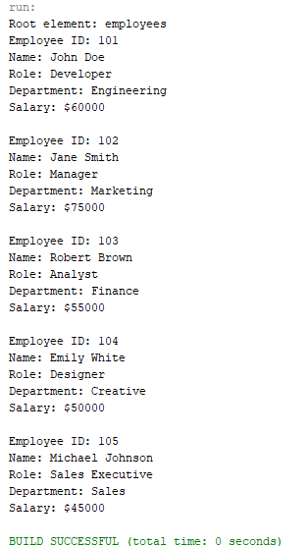

**SAXParser**

